UDC 636:338.439.4
Vyshnevska О.М.,
Doctor of Economic Sciences,
Professor of Economic Analyzing and auditing Department,
Mykolayiv National Agrarian University

Ecological priorities in the Economic Development of Ukraine

Statement of a problem. Developing of any economic or productive system is related to the necessity of sustainable framework, based on the economic, social and environmental benefits. The combination of all the components can be justified from a theoretical point of view, to identify areas and mechanisms for the implementation on some certain areas of economy. In practice, it is hard to combine the aspects of sustainable development and to define the prioritize of implementation of some specific development programs at the national, regional and local levels. [1]
In the conditions of the world economic globalization, the aspects of sustainable development are prioritized by the need to address the environmental issues, which are offset by the financial priorities in the development of any business. The measures of the sustainable development are particularly relevant for the agricultural sector, which has a close relationship with the biological characteristics of natural resources, including regional characteristics of the territory, its ecological status and definite actions to minimize the environmental risks. The processes of globalization, especially in recent years, are associated with significant negative impacts on some ecosystems that are rapidly losing opportunities to self-healing. Almost all of the world development programs include the measures which are directed at the conservation and reproduction of certain types of natural resources, the implementation of environmental protection measures at different levels [2].
The significant amounts of financial resources for the environmental issues at the global level due to the dangerous global are mobilized. The impact of the measures to stabilize the environmental situation remains inadequate. It is confirmed by the information on the destabilization of the environment, which had covered up to 64.0% of the earth's surface. In the early twentieth century, only 20.0% of the earth's surface was occupied by the completely damaged ecosystems.
Analysis of recent research and publications. Various aspects of the economic and environmental relations with the limited resources and the increased pressure on the environment were researched by the national and foreign scientists among whom there are O.F.Balatskyy, O.O.Veklych, B.M.Danylyshyn, S.I. Doroguntsov, O.I. Kotikova, L.G.Melnyk, P.T. Sabluk, V.M. Tregobchuk, M.A.Hvesyk and others.
Environmental priorities in securing of further social and economic development are superior due to lower biological features of some types of natural resources to self-healing. Most of the innovation-oriented countries of the world implement the appropriate national and regional programs to minimize the environmental risks and ensure the long-term environmental safety.
The tasks statement. Our research is directed at the grounding of components and potential opportunities to limit the negative impact on the environment, based on the consistency and comprehensiveness of the actions and their sequence. The study aims to study the nature and components of the ecological security formation, identifying cause-and- effect relationships in the use of certain types of natural resources in order to minimize the negative impact of environmental risks through the activation of investment and innovation processes, improving the technological readiness and the implementation of innovative technological solutions in the economic spheres of Ukraine.
The main material of research. Negative trends in environmental conditions are associated with technological pressure on the certain types of natural resources. It requires the activation of investment and innovation, particularly in resource-intensive industries. Innovative updates in the field of greening agriculture are widely introduced in the European Union, the USA, Canada and Australia. A particular aspect of the global environmental crisis is not only the high level of environmental capacity of the created product, but also the accumulation of waste of economic activity in the environment, including chemical synthesis and toxic substances. The prevalent environmental impact on the environment is made by the developing countries with up to 1.0 million tones of hazardous waste every day.
Solving of environmental issues in the certain areas of the economy in the regions, countries or even in some continents has a direct connection with environmental safety, the essence of which is to provide a balanced interaction of natural, technical and social systems, forming natural and cultural environment that meets the sanitary and hygienic, aesthetic and material needs of each region of the Earth by saving natural resources and the ability of natural systems of the biosphere to self-regulation.
Significant event in the development of modern ecology was the International UN Conference on Environment and Development. The Resolution of the Conference had announced the international principles of environmental development, which are based on the foundation of the international strategy for sustainable and balanced development. The essence of development is the harmonious interrelations between society and nature, which is built on the principles of non exhaustion and mutual responsibility [1].
The announced International Strategy of Sustainable Development has been operating for 22 years, but the overwhelming number of applications is costly and requires the involvement of the relevant investment resources to intensify the introduction of "eco-innovation" targeting measures at national level to prioritize the development of "green economy". The most expensive is a program to clean the certain types of natural resources and the creation of appropriate conditions for sustainable use with the opportunities of renovation.
Taking into account the current trends of the ecological security formation on the national level is an essential condition for sustainable economic and social development. The ecological balance is the responsibility of the state. Environmental security has to be considered through the political, legal, economic, technological and other measures which are aimed at the environmental protection of each person from the possible negative impact of economic and other activities, and threats of natural and man-made disasters in the present and future time.
According to the processed literature it cam be revealed that environmental security is a combination of natural, social and other conditions for safe life and activity of population in a specific area. Environmental security can be examined through the actions which are directed at the preservation of the environment and opportunities for further distribution of the population. Environmental security can be seen through the actual level of the ecological condition of a particular area or certain types of natural resources, taking into account the potential risks, both of internal and external types. In order to ensure the environmental safety it is necessary to create definite conditions to minimize the adverse environmental impact that can be achieved only through the activation of appropriate measures at the national level and include ecosystems at various levels and of different origin.
Environmental security is closely related to the innovation and investment, the biological characteristics of ecosystems, natural zoning, because the territorial factor will form the appropriate basis of management decisions in the direction of minimizing the environmental risks. Formation of the ecological security should be based on the actual condition of ecosystems and the range of actions to ensure an appropriate level of protection against potential risks in the short and long term. The actual situation with ecosystems is estimated by the determination of the environmental risk on a territorial basis. The detailed assessment is conducted to identify the potential of certain types of natural resources to heal itself taking into account the climatic features.
The further development of the sectors of the economy requires raising and capacity for modernization, introduction and adaptation of new technologies, including ecologization. In terms of technological readiness of the economic sectors which are included in the overall index of global competitiveness of the country, Ukraine is on the 84 place in the world, which requires the implementation of appropriate measures at the national level in order to promote investment and innovation processes in the further development of the country. Technological readiness is very importance for the country's competitiveness, because Ukraine has moved into the second stage of economic development in accordance with the methodology of the World Economic Forum. [4] And in the second stage of economic development - the stage of "performance orientation" - the competitiveness index is greater and the impact of indicators in the group of "amplifier efficiency", which are the part of the "technological readiness», is also greater. The level of technological readiness of economic sectors is characterized by agility, with which the economy adopts the existing technologies to increase the payback from the investment due to the implementation of new technologies and the ability of the economy to use the information and communication technologies (ICT), which are able to convert into " the general purpose technology" and play the role of industrial infrastructure.
Thus, technological readiness is an important part component of the conditional formation to attract the investment capital for the further development of innovative industries and enhancing of the ecological programs.
Using the information of the World Economic Forum let’s hold a rating of technological readiness of the economy among 144 countries in the dynamics (Fig. 1).
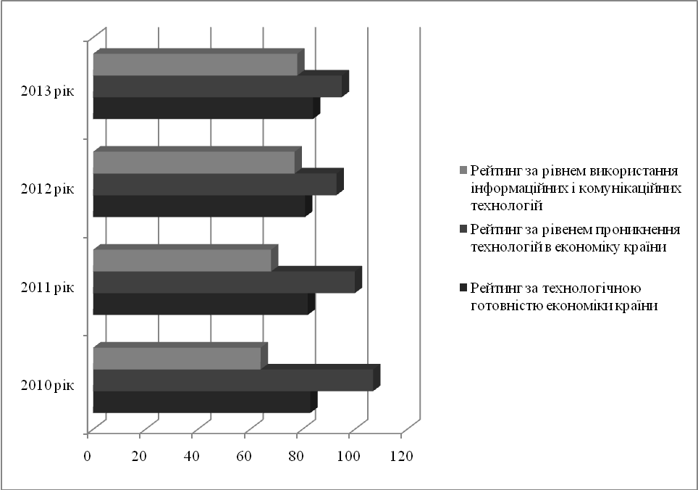
Figure 1. The rating of the economy according to the level of technological readiness in the dynamics, scores.
The source: The Information is submitted using the World Economic Forum [4]

Over the studied period there is no significant change in the rating of the indexes. It proves the necessity of improving the business environment and the creation of appropriate safeguards to investors, as a favorable investment climate requires appropriate business activities of all stakeholders and appropriate levels of integrity in the conduct of any business that will attract new technological solutions in the field of economy.
One of the prospective ways of technological innovation is the greening of industries, actively introduced in the European Union in order to minimize environmental risks. Ecologization of the production is aimed at the spreading of environmental principles and practices in the industrial and social spheres of the economy. Providing opportunities in spreading environmental development is associated with a set of relevant social, economic and technological solutions which are aimed at ensuring of ecological balance.
Formation of the environmental safety at the national level is closely related to the investment and innovation impact factors, which depend on the level of technological readiness of industries and opportunities to implement the innovative technological solutions to reduce negative environmental impacts, providing conditions for self-healing of natural resources.
Conclusions. The research on the environmental priorities in the development of the economy takes place because of the economic and social interests in order to minimize the negative impact on the environment. The implementation of the systematic and consistent national and regional programs in the direction of preserving ecosystems, activation of cleaner production to reduce environmental risk is possible only if the orientation of the further development of economic sectors for investment and innovation framework. Attracting new innovative solutions requires improvement of technological readiness and enhancing of the process of implementation based on ensuring appropriate investors’ rights. The combination of environmental priorities of economic sectors is a prerequisite for the development and focus on the formation of innovation - oriented economy type, taking into account the needs of modern society, natural resources and their conservation for the future generations.
Література:
- Вишневська О.М. Ресурсний потенціал аграрного сектора економіки України: соціально-економічні та екологічні аспекти. [Монографія] / О.М. Вишневська. – Миколаїв: «Дизайн і поліграфія», 2011. – 436 с.
- Вишневська О.М. Ресурсний потенціал підприємств сільських територій / О.М. Вишневська : [монографія]. — Миколаїв, 2009. — 248 с.
- Звіт про конкурентоспроможність регіонів України. Фонд «Ефективне управління» Всесвітній Економічний Форум [Електронний ресурс]. — Режим доступу : http://feg.org.ua
- Balassa B. Trade liberalization and Reveal Comparative Advantare // Manchester Scholl of Economic and Social Studies. — 1965. — Vol.33. — p. 78—96
- Hinloopen J., Marrewijk C. On the Empirical Distribution of the Balassa Index // W.P. Erasmus University Rotterdam.—2000. — p. 60—75.
- Berdegue, Julio A., Reardon T., Escobar. G. (2000): Policies to Promote Non-Farm Rural Employment in America. Overseas Development Institute, London [Електронний ресурс]. — Режим доступу : http: // www.odi.org.uk.
- Bright H., Davis J., Janowski M. et al (2000) Rural Non-Farm livelihoods in Central and Eastern Europe and Central Asia and the Reform Process: A Literature Review. Natural Resources Institute, UK. [Електронний ресурс]. — Режим доступу : http:// www.nri.org/rnfe/pub/papers/2633.pdf.
- Von Meyer H. Rural employment dynamics in the EU // Von Meyer H., Terluin I., Post J. / Hague, Netherlands.— 2008.— 112 p.

References:
- Vishnevskaya О.M. Resource potential of the agricultural sector of Ukraine: the socio-economic and environmental aspects / О. Vishnevskaya [monograph]. — Nikolaev, 2011. — 487 p.
- Vishnevskaya O.M. Resource potential of the rural area / O. Vishnevskaya [monograph]. — Nikolaev, 2009. — 248 p.
- Report on the competitiveness of regions of Ukraine. Fund "Effective management" World Economic Forum [Electronic resource]. – Access : http://feg.org.ua
- Balassa B. Trade liberalization and Reveal Comparative Advantare // Manchester Scholl of Economic and Social Studies. — 1965. — Vol.33. — p. 78—96
- Hinloopen J., Marrewijk C. On the Empirical Distribution of the Balassa Index // W.P. Erasmus University Rotterdam.—2000. — p. 60—75.
- Berdegue, Julio A., Reardon T., Escobar. G. (2000): Policies to Promote Non-Farm Rural Employment in America. Overseas Development Institute, London [Electronic resource]. – Access : http: // www.odi.org.uk.
- Bright H., Davis J., Janowski M. et al (2000) Rural Non-Farm livelihoods in Central and Eastern Europe and Central Asia and the Reform Process: A Literature Review. Natural Resources Institute, UK. [Electronic resource]. – Access : http:// www.nri.org/rnfe/pub/papers/2633.pdf.
- Von Meyer H. Rural employment dynamics in the EU // Von Meyer H., Terluin I., Post J. / Hague, Netherlands.— 2008.— 112 p.

